**4**

TURNING CONTROVERSIES INTO QUESTIONS OF

DESIGN: PROTOTYPING

ALTERNATIVE METRICS FOR HEATHROW AIRPORT

*Christian Nold*

*It is difficult for a measure to command public confidence when it effectively tells people living in places like Barnes, Fulham, Putney, Ealing, Chelsea, Stockwell and Windsor that they are not affected by noise because they live outside the Heathrow contour*

Airportwatch 2013

# Introduction

public controversies about techno-scientific issues such as food safety and environmental pollution have been extensively studied by scholars of science, technology and society. Classic work in this field has highlighted the political and epistemic aspects of such controversies, focusing on the ways in which knowledge becomes political when disagreements about seemingly technical issues like the above are made public through media reporting, activist mobilisation, court hearings, government consultations and so on (Nelkin 1997; Wynne 1992). More recently, authors such as Braun & Whatmore (2010) and Marres (2012) have insisted on the important role that materials and technolo- gies play in the enactment of controversies about techno-scientific issues in social

and public life. Building upon this literature, this chapter offers methodological and theoretical reflections on the project of turning public controversies into occasions for and questions of design. These reflections are the outcome of a three-year-long research project that investigated and engaged with a controversy over aircraft noise at Heathrow airport in London (Nold 2017). I describe the process of coming to understand the infrastructures that were at stake in the Heathrow controversy, and of designing prototypes to support the formation of new socio-technical collectives around the issues. I argue that such design- led approaches have the potential not only to help us understand but also to intervene in public controversies about science and technology.

# Heathrow as a Controversy

Heathrow is the world’s third largest airport, with 73.4 million passengers pass- ing through it every year (Heathrow Airport 2015), making London the city with the highest aircraft noise exposure in Europe (Mayor of London 2013). Yet there have been many calls to expand the air travel capacity in the south east of England, and in 2013 the Airports Commission was set up to establish which of the three London airports should be expanded. In 2015 the commis- sion recommended the expansion of Heathrow with a third runway, and this was expected to generate £147 billion in additional Gross Domestic Product (GDP) over the next sixty years (Airports Commission 2015). Yet expansion would bring more flights and road traffic, and more people would be affected by aircraft noise. The issue of the airport’s impacts is highly emotive, and it was and is being kept in the public eye by, among other means, ongoing media reporting of studies on air quality, health impacts and economic benefits. In many of these studies, the issue of Heathrow’s expansion is framed in terms of a trade-off between addressing the ‘annoyance and disturbance suffered by some local residents as a result of aircraft noise, while at the same time continuing to maximise the social and economic benefits that the airport delivers to the local community and the country as a whole’ (Heathrow Airport Limited 2013: 7). While the Airports Commission has recommended the expansion of Heathrow,

the government has repeatedly postponed its final decision, since it is seen as a ‘toxic dilemma’ (Kuenssberg 2015) that is likely to alienate large parts of the national electorate.

My own involvement with the Heathrow controversy started in 2012 in the context of an EU-funded engineering research project. This project distributed cheap environmental sensors to members of the public, who were encouraged to collect noise pollution data in response to the European Noise Directive (European Parliament 2002), which requires the production of EU-wide noise maps. Heathrow airport was one of the case study sites, and my role in the project was to facilitate the use of a smartphone app for gathering noise data with local residents, and to manage interactions with local groups. During the project both the participants and the researchers were frustrated by the usage-protocol of the smartphone application, which was not suited to capturing aircraft noise, and by the fact that the device was not sophisticated enough to generate results that would be comparable with the official noise data. When the project came to an end, I spent two years working in the area and, having become engaged by the issue of Heathrow expansion, I wanted to continue working with the controversy. During the EU-funded project, some of the stakeholders, such as the airport authorities, local councils and residents had requested static noise monitors that could be widely deployed across the area to track changes in flight patterns and produce data that could be compared with the official dataset. This request was not considered to be part of the EU project’s goals, and was not fulfilled. However, it gave me a concrete starting point for my own research, as well as raising a number of challenging questions: who should I be designing noise monitors for? What exactly should the devices do, and what contribution should they make in relation to the noise controversy?

# Infrastructuring Controversies

Engaging with the Heathrow controversy through monitoring devices required a way of understanding it as a site for design. I therefore start this section by discussing work in participatory design that engages with social studies of

science and technology and public controversies. Participatory design in the Scandinavian tradition defines itself as a shift away from designers as experts towards the wider participation of users in the design process (Ehn 1988). In this tradition, designers have sought inspiration from the STS concept of ‘infrastructure’ (Star and Ruhleder 1996), which moves away from mechanistic visions of technology as tubes and pipes, towards infrastructure as a connec- tive resource that links people, organisations, standards and ‘object worlds’. In this vision ‘infrastructure is fundamentally and always a *relation,* never a thing’ (Star and Ruhleder 1994: 253; emphasis in original). From this vantage point, building new infrastructures involves coordinating and facilitating the ‘demands of multiple groups and making connections between them possible’ (Neumann and Star 1996: 234). Infrastructure allows different practices to coexist: ‘the cook considers the water system a piece of working infrastruc- ture integral to making dinner; for the city planner, it becomes a variable in a complex equation’ (Star and Ruhleder 1996: 113). Once built, infrastructure fades into the background, and it becomes the researcher’s role to carry out an ‘infrastructural inversion’, to bring it back into the foreground, in order for it to become investigable.

Participatory designers have adapted this concept of infrastructure into an active method of ‘infrastructuring’ (Karasti and Syrjänen 2004; Ehn 2008; Björgvinsson et al. 2010; Hillgren et al. 2011; Björgvinsson et al. 2012; Le Dantec 2012; DiSalvo et al. 2014). This method embeds designers within a community in order to actively support this community over an extended period of time (Karasti 2014). Instead of the more clearly defined infrastructures of workplaces on which Star and Ruhleder’s work focuses, the design method of infrastruc- turing targets social and political collectives assembling around issues, a focus inspired by Actor-Network Theory (Latour and Weibel 2005; Marres 2007). For example, Ehn (2008) talks about designing in order to target an object of concern, which would bring together a group of participants around an issue. Moreover, Disalvo et al. argue that design artefacts can ‘expose and re-imagine constraints and parameters surrounding issues’ (2014: 205), as well as function as ‘scaffolds’ for the ‘affective bonds that are necessary for the construction of publics’ (Le Dantec and DiSalvo 2013: 260). So, while Star and Ruhleder’s

notion of infrastructure is attuned to organisational and professional contacts, participatory designers are especially interested in infrastructure defined as a public and political affair. Yet I argue that participatory design has placed too much emphasis on the way infrastructures create connections between humans, and not enough on the way these infrastructures constrain and reinforce prac- tices. For example, when creating a mobile phone communication system for a homeless shelter, the designers conceived the staff and residents as separate publics with different issues of concern (Le Dantec et al. 2011). At the end of the project, the designers discovered that their system had created two differ- ent issue outcomes. It had highlighted an issue of accountability for the staff, whilst for the residents it had organised their household chores. By choosing to situate the infrastructuring design process within an existing institution, it became difficult to transcend the underlying dynamics of the homeless shelter. In fact, the asymmetrical system the designers built seems to have reinforced the existing relations and distinctions between staff and residents. In order to turn controversies into questions of design, one needs to engage critically with the existing elements that comprise a controversy, and not only to build new relations.

In order to expand the notion of infrastructuring to address the composition of controversies, I turn to a concept of ‘scaling’ taken from early Actor-Network Theory (Callon and Latour 1981). This concept offers an alternative approach to the structure-agency distinction that assumes a hierarchy between a macro- actor such as the state and a micro-actor such as an individual. Callon and Latour argue that macro-actors are not innately large and important, but that their ‘size’ is the result of processes of enrolling many human and non-human actors in order to increase their size. In their words: ‘we cannot distinguish between macro-actors (institutions, organisations, social classes, parties, states) and micro-actors (individuals, groups, families) on the basis of their dimensions, since they are all, we might say, the “same size”, or rather since size is what is primarily at stake in their struggles it is also, therefore, their most important result’ (Callon and Latour 1981: 279; emphasis in original). I argue that this concept of re-scaling actors through association adds three important points to the concept of infrastructuring social and political collectives.

First, it suggests that the size of an existing institution might be unrelated to its importance within a specific controversy. This means that participatory designers do not necessarily have to engage with existing institutions as gate- keepers for defining the scope or boundary of an issue. Second, it suggests that by assembling human and nonhuman actors into infrastructures, participatory designers are involved in a constitutive process of scaling that creates new onto- logical entities and realities in the world. Finally, the implication is that such an ontological approach changes the role of the designer, thus requiring them to make new kinds of choices. The role becomes one of ‘immersing oneself in the networks described and searching for what is or can be achieved by new interlockings of artefacts and human work’ (Berg 1998: 482). This brings with it what the anthropologist Mol calls an ‘ontological politics’ (1999) that involves identifying whether it is possible to build alternatives and develop ways to live with the infrastructures that cannot be changed. Designing thus involves political and ethical choices that will result in the inclusion and displacement of actors within the composition of new infrastructures.

# T he I nfras tructure of the Heathrow Controversy

How are these approaches and the concept of infrastructuring social and political collectives applicable to the Heathrow controversy? If one looks at this controversy through the lens of a ‘material’ definition of infrastructure, one sees only aircraft, acoustic pressure and measurement devices. If one looks through a purely ‘political’ lens, one sees politicians, industries and residents. By apply- ing the concept of relational infrastructure, however, one sees new connections across the material and political registers, such as techniques and metrics that mediate between the aircraft, local residents and the legislative authorities by measuring and governing the impact of the airport. A discussion of the issue of Heathrow noise pollution can help to make this clear.

Aircraft noise emerged as an issue at Heathrow with the introduction of turbo-jet aircraft in 1958, and it occasioned a survey of the impact of aircraft

sound on humans (MIL Research Limited 1961). This was the first of three significant UK-based studies in which standardised interviews of residents were carried out and compared with the measurements of acoustic energy. Residents were asked how much the aircraft noise bothered them: ‘very much, moderately, a little, not at all’, and the responses were compared against local acoustic energy measurements. The data were used to create a dose-response relationship that was intended to predict community annoyance at increasing noise levels. While it is acknowledged that these metrics are poor predictors of individual or group annoyance, their goal is equity and a consistent noise policy for the ‘general population’ (Miedema and Oudshoorn 2001). The result of the 1961 study was the creation of the Noise and Number Index (NNI), a metric that has three threshold points denoting high, moderate and low community annoyance (Civil Aviation Authority 1981). Using models of sound dispersion, these threshold levels were then plotted on maps as exposure contour bands radiating out from the runways, effectively defining the people living within each contour as experiencing a set level of annoy- ance. The NNI metric was designed for ‘estimating the total disturbance at the time of the surveys *and* a way of estimating the disturbance resulting from a change in the scale or pattern of airport operations’ (Brooker et al. 1985: 1; emphasis in original). Its goal was thus as a policy instrument for forecasting annoyance, and for the last fifty years, the metric and its succes- sor, LAeq, have been used as a calculative infrastructure to determine how many people are affected by the noise of Heathrow. People living within the modelled noise contour bands are defined as differently affected by noise in order to provide them with commensurate levels of financial compensation and subsidised sound insulation, while those living outside the bands are not compensated. Crucially, the number of affected people is also used as the basis for future decisions about the airport. The 2015 Airports Commission report (Airports Commission 2015) used the number of people within the 57 LAeq contour as the key indicator of local impact when comparing the different airport options and when it recommended building the third runway at Heathrow. This diagram describes the way noise metrics are assembled and function:

survey responses + acoustic measurements =

annoyance contours > number of people affected

> governance decisions

One way to understand the construction and function of community annoyance in scalar terms is by using the metaphor of the Leviathan as taken up by Callon and Latour (1981). The authors use this metaphor to describe the way collec- tive capacities comes to be consolidated within a single entity. The Leviathan represents the power of a king, and is visually represented as a crowned giant that is physically assembled from the bodies of all his subjects. Callon and Latour proposed that this visual image of the Leviathan can be interpreted as an allegory for the constitutive power of macro-actors. In their words: ‘The construction of this artificial body is calculated in such a way that the absolute sovereign is nothing other than the sum of the multitude’s wishes’ (Callon and Latour 1981: 278). However, while Callon and Latour use the metaphor to understand the capacities of social actors (such as scientists and engineers) I argue that community annoyance can be conceived as a Leviathan figure insofar as it acts as ‘spokesman, mask-bearer and amplifier’ for the collective of humans living under the flight path at Heathrow. Crucially, the local residents are extremely frustrated with the way community annoyance speaks on their behalf. Here is one resident’s response to the Airports Commission: ‘Heathrow are exploiting the 57dB noise threshold to make it look like there is a reduction in noise with an expanded airport. The reality of course is that noise continues to be hugely disturbing to many people considerably below that threshold, me included. Where I currently live, whilst better than Kew (hence I moved here) and just outside the 57dB contour is still disturbing enough to wake my children regularly’ (Airports Commission 2013: 2).

We could say of this contested quality of the annoyance metric that it functions as an ‘infrastructure’ of the Heathrow controversy, since it connects aircraft, residents and politicians, and plays a key role in decision-making. Yet this connection is asymmetrical, since this annoyance spokesperson is used to dismiss individual resident’s claims of affectedness and to disqualify them from being personally consulted. The 57dB threshold figures as an important actor in

the narratives of the opponents to expansion, yet the metric is largely invisible within the broader public debate about the controversy. There was only a brief period in which the metric became a publically visible actor, and this was as a result of a controversy around a particular noise impact study. In 2007, the major, Government-sponsored ANASE study (cost £2,000,000) found that commu- nity annoyance started at much lower noise levels than identified in the 1985 study (Le Masurier et al. 2007). These findings suggested that the Heathrow annoyance contours should extend much further and envelop a much larger number of people. This was seized on by the media and opponents of the airport who argued that the ‘true number affected by Heathrow operations is around 1m[illion] – four times the figure implied by the 57dB contour’ (Airportwatch 2013: 3). The outcry increased when the ANASE study was officially dismissed for methodological discrepancies. Despite the fact that many high-profile politi- cians, local councils and pressure groups argued strongly against this dismissal, and pointed to the problems of the 57dB contour, the official legislative standard has remained at the level of the older 1985 study.

How is it possible that, despite the loss of public confidence in it, the metric has remained in place? The technical acoustics literature, from which this and related metrics are derived, is actually ambivalent about them, arguing that the variations among noise metrics are ‘more a matter of convenience than any reflection on the strength of any assumed underlying dose-effect relation- ships’ (Flindell 2003: 36). This quote suggests that these metrics are not simple empirical facts in or about the world, but pragmatic, or ‘interested’ tools that enable convenient management of the controversy. In the case of Heathrow, large amounts of data have been accumulated using a single metric, making comparisons between different operational proposals simple and convenient. While the above controversy around the ANASE study allowed the 57dB annoyance contour to briefly come to the foreground, the media’s main focus is on the political choices that are presented as either ideological or pragmatic trade-offs between economic benefits and alienating certain voters. I suggest that the airport opponents’ lack of success in challenging the metric may be due to the fact that they have been unable to politicise the lack of care involved in the way community annoyance has been measured.

Yet there are some interesting aspects to the dismissal of the ANASE study that point to an alternative method for intervening in the controversy. The official reason given for the rejection of the study cited specific procedures conducted during the interviews. The reviewers of the study discussed a number of meth- odological issues but focused on the interview process that took place in people’s homes and included portable audio speakers. They argued that, ‘the act of setting up and calibrating equipment would almost certainly have enabled respondents to deduce that the study was about attitudes to noise. Furthermore, the fact that the social survey sites selected were located away from other sources of noise may have enabled some respondents to conclude that the study pertained to aircraft noise’ (Civil Aviation Authority and Bureau Vertias 2007: 16). The reviewers thus concluded that, ‘there is a risk that the social survey results may have been contaminated by respondent bias. That is, respondents may have used the opportunity to voice their opinion on the Government’s aviation policy and may have either deliberately or sub-consciously exaggerated their reaction to aircraft noise in the way they answered the question’ (ibid.). The reviewers’ argument is that the presence of the audio speakers triggered the respondents into thinking the study was about aircraft noise and aviation policy and that, because of this, the residents exaggerated their responses.

The ANASE authors published a report refuting these points. In regards to the loudspeakers they suggest these ‘were not in fact used until after the key annoyance questions had been dealt with’ (Ian Flindell & Associates and MVA Consultancy 2013: 12). Yet more broadly, they argue that the issue of the speakers is part of a broader disagreement with the reviewers about the reality of annoyance and how it should be staged. They argue that the ‘review group’s comments suggest a fundamental misunderstanding of the nature of noise annoyance, that it is somehow some kind of underlying and fixed physiological or neurological response to noise which is always the same regardless of any changes in attitudes and opinions in the people concerned’ (ibid.). The authors suggest that it is impossible to isolate annoyance from the politics of aviation policy and that it would be ‘impossible to ever find a “good” time to be able to carry out a supposedly unbiased aircraft noise questionnaire survey’ (ibid. 11; emphasis in original). What is at stake is an ontological disagreement about different ways

of staging community annoyance, as neurological and disembodied, on the one hand, or as pragmatically embodied with sound equipment and situated within political arguments, on the other. The controversy around the ANASE study reminds us that there are many practical choices to be taken when curat- ing situations in which people can provide evidence of their experience. These include choices about the context in which residents are asked questions and the physical props that are present during the interview, as well as the manner in which the questions are asked. If we go along with the idea that the respondents were strongly affected by the mere presence of the speakers, then this suggests that the articulation of annoyance may be approached as a creative occasion for public experimentation, one in which a multiplicity of different elements might be introduced to generate new articulations of annoyance. The end effect would be that, rather than having a single way of defining and measuring annoyance, there would be multiple competing compositions.

This episode shows that there is not one but several controversies around noise at Heathrow: a media controversy focused on economic trade-offs, a failed political controversy about the number of people affected by noise, and an ontological controversy surrounding how to articulate annoyance as a matter of concern. Targeting the ontological controversy raises the question of how a more suitable annoyance metric could be created, what elements it should consist of, and how such a design process could be publicly legitimated. Interestingly, a number of acousticians who have worked with social survey methods for decades are now proposing a shift towards spontaneous self-reporting of com- plaints by residents as a way of bringing back transparency and legitimacy into noise governance. Fidell argues that noise complaints were abandoned in the 1970s because they ‘were difficult to process and systematically compare, largely inaccessible to researchers, and generally awkward to interpret’ (Fidell 2003: 3012). He argues that the growing use of distributed, networked computing devices is making it possible for geographically tagged noise complaints to function as a new metric. Adopting such a system would shift annoyance from a given neurological concept-measure into an active process of resident par- ticipation. The key aspect of this shift in register is that it turns annoyance into a phenomenon partly dependent on curation processes, and hence involving

questions of design, which invariably raises a multitude of practical questions around how to stage annoyance.

# Infrastructuring Heathrow

My investigation of how to turn the Heathrow controversy into a site for partici- patory design has, then, yielded an answer to the question of who to design for. Instead of setting out to create a project for a particular group of residents or an institution handling the issue, my aim was to carry out participatory design with the infrastructure of the controversy itself. Rather than being accountable to a human client, my task was to become responsive to the issue itself. My research also provided me with a design target in the form of the annoyance metric, as well as a methodology, namely that of infrastructuring social-political collec- tives by using ‘micro/macro prototyping’ techniques (Nold 2015). My goal was to build an alternative Leviathan, one that differed in crucial respects from how the annoyance metric composed the public. My alternative ‘body politic’ would be composed of new entities and would ideally be able to compete with the existing metric in a kind of robot battle over who has the right to wield the authority of collective experience. To begin this process of re-composition, I decided to create a series of design prototypes consisting of custom hardware and software to test with the interested parties.

My prototypes were intended as material-semiotic devices that are simul- taneously *things* as well as *concepts* in order to set up new propositions about the relationship between aircraft, residents and governance. Each prototype was a composition that proposed different ways in which the noise issue might be handled by inserting or removing material, symbolic or computational ele- ments. The prototypes have names that identify the specific propositions they present, and this reinforces the notion that each prototype is a unique actor with its own distinct voice. The aim of the prototypes was not to seek approval for the designs but to allow the participants to experience and articulate new infrastructural compositions and to build alternative networks of human and nonhuman actors that might challenge the existing annoyance metric. I took

the four initial prototypes to potential partners who might want to join the process, such as the airport administration, local councils and residents. During the meetings and workshops, the prototypes were used as props and demon- stration devices. The following vignette describes one of these workshops at a community centre located under the Heathrow flight path, with nine residents who did not know each other beforehand. During the workshop, planes could be heard overhead at regular intervals.

# Prototype 1 : ‘ I Speak Your Feelings ’

The first prototype (Fig. 4.1) samples the voltage sensed by a microphone and translates this into a phrase displayed on a LCD screen. Instead of decibel numbers, the screen displays sound level using a scale of emotive words: quiet, audible, loud, very loud, extremely loud, and painful. The words on the screen

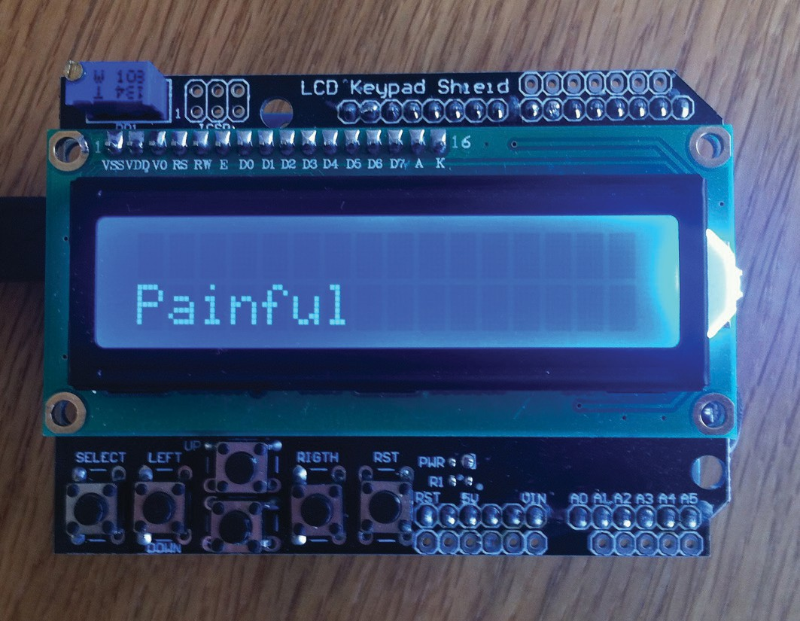

**Fig. 4.1** Photograph of the ‘I speak your feelings’ prototype (photo: Christian Nold)

change continuously in response to sudden sounds. The prototype uses the dose-response logic implied by the community annoyance metric and turns it into a tangible object that can be placed on a coffee table. The machine experiences sound pressure on behalf of humans, which is transformed into an emotive language without people being involved. The prototype is designed to performatively highlight the simplistic relationship between measured acoustic pressure and annoyance level that the current metric relies on. This diagram represents the composition and function of the prototype:

sound sensor > translation into annoyance words

> lcd display

When the device was presented to the workshop group it acted as a catalyst for the participants to talk about the way noise affects them in their daily lives, such as, ‘I don’t want to cut myself off, which is really what noise is about, it is cutting you off ’. They identified elements that the current LAeq metric does not capture, such as the interval between flights and the harmonics of noise, with someone arguing that ‘it’s not just decibels, there is something else in there as well’. The participants discussed ‘a more complex device which will analyse the sound and tell you about the interesting element of the sound harmonics and different pitches’. In addition, some suggested alternative ways of providing evidence of their experience, such as by measuring their physiological responses to noise. Yet two of the participants seemed frustrated: ‘I think it would be completely chaotic if you just had people’s feelings about it. What would you do with that data? You have got to have an objective reference’. Their argument was that ‘for the purposes of any kind of campaign it’s got to be objective. So, its amounts of particles per million, it’s got to be measurable rather than […] smelling’. At this point another participant interjected that social policy uses anecdotal stories as evidence in conjunction with statistical data.

During the workshop, the reductive emotive words displayed by the proto- type seemed to spur the participants into describing the limitations of the cur- rent noise metrics when it comes to their ability to encompass their experience of noise. This triggered a process of reflection on different ways of evidencing

the impacts of noise. While it was widely agreed that evidence was needed, there was disagreement as to which method or technology would provide the greatest political legitimacy for campaigning. Yet the participant who was most vocal about the need for an objective reference said, ‘is it really worth debating this? I mean people have different opinions, why don’t people contribute what they contribute from their perspectives’. He followed this with an enthusiastic exclamation of ‘take it all’. The main observation I took from this prototype interaction was the pragmatic suggestion of combining different evidential methods in order to build a cohesive collective around the issue.

# Prototype 2 : ‘ I Display Noise Publicly’

The second prototype (Fig. 4.2) consists of a mock-up of a large noise meter display mounted on the exterior walls of a building. The device illuminates when a specified noise level is exceeded. The prototype investigates where the issue of noise should be located and whom it should address. It is based on the observation that the geographical area around Heathrow looks like many other suburban areas in Britain, with the built environment not providing any visual reference to the noise overhead. Many of the residents I had been in contact with talked about aircraft noise in the context of their private homes, and described its effects in a solitary and personal way. As a provocation, this prototype locates the issue of noise outdoors within public space. In the workshop, I introduced the prototype as something that could be mounted on the participants’ houses as a way of engaging their neighbours, and I described a scenario in which a plane coming in to land at night would see the ground light up as it flew overhead. The composition and logic of the device is as follows:

sound sensor > outdoor warning display

> addressing a proximate public

During the workshop, it quickly emerged that the participants were excited by the device, yet no-one wanted to fix it onto their own home. Instead they suggested

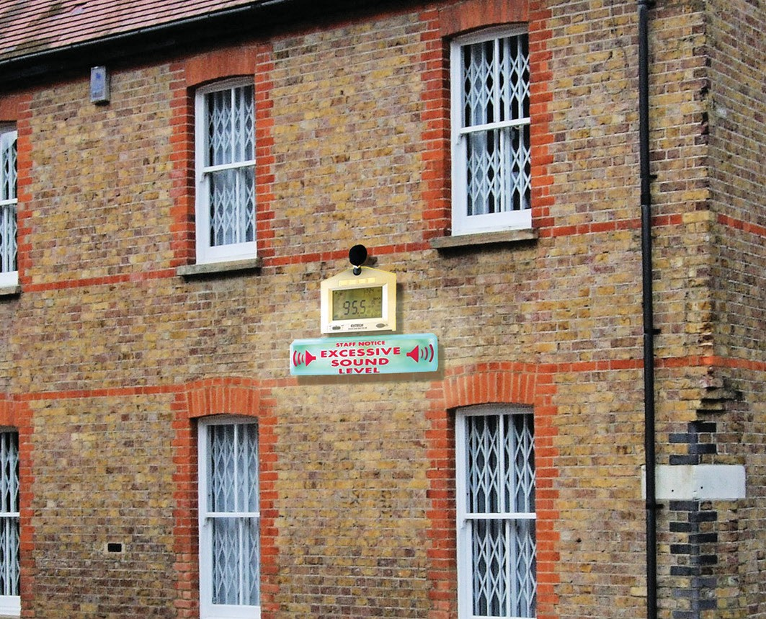

**Fig. 4.2** Image mock-up of the ‘I display noise publicly’ prototype (photo: Christian Nold)

that it should become a ‘norm’ to have it installed on public buildings such as offices and schools. One of the participants suggested that mounting it on one’s own house could have negative consequences: ‘I don’t want to be a downer on this, but we do have to bear in mind that people think that campaigning and emphasising the noise problem is giving them a problem. Because it affects the value of their house and they might want to sell their house and they don’t want to be labelled as a problem area. And we have found that schools have quite remarkably low levels of interest because they get money out of the airport for various activities and they don’t want to be seen as the wrong school to send your child to’ (Others nodded and voiced agreement). This interaction clearly identified an aspect of the prototype that I had not considered. Placing the device on one’s own home would characterise the immediate area as affected by noise and would make the resident personally identifiable as a campaigner, which could have direct negative effects for that person.

The prototype identified a tendency to privatise the issue of noise pollution, namely, to locate noise within individual people’s homes and to not define it as a collective problem. This atomisation of the issue is reinforced by the remedial measures that the airport offers, which focus on noise insulation for individual homes rather than public spaces. This effect can also be seen in the telephone hotline infrastructure the airport has set up to allow individuals to make com- plaints. What is absent are public platforms that allow local residents to engage with the noise controversy collectively. Taking into account the participants’ responses highlighting the dangers of public campaigning; this prototype interaction suggested to me a need for a sound-monitoring network that could discreetly connect individuals’ homes and institutions.

# Prototype 3 : ‘ I Make Someone Responsible ’

The third prototype (Fig. 4.3) is programmed to send an SMS text message to a mobile phone whenever a peak decibel level of 90dB is exceeded. The prototype is based on conversations with residents in which I felt there was a lack of clarity as to who or what is responsible for noise pollution. Whole ranges of entities were identified, including local and national government and its agencies, the airport, individual airlines, and capitalism. The provocation of the prototype is to choose a single entity that might be held directly responsible. The logic of the device is as follows:

sound sensor > sms alert > target an individual entity

When I introduced the prototype, I showed the workshop participants the source code of the micro-controller, and mentioned that the mobile number could be changed to anybody’s phone number. Suddenly a dramatic change of atmosphere occurred, with all the participants laughing loudly, as they under- stood the implication of inserting somebody else’s number into the source-code. The participants excitedly discussed a range of potential entities that could have their number inserted, including airport complaint phone-lines, institutional

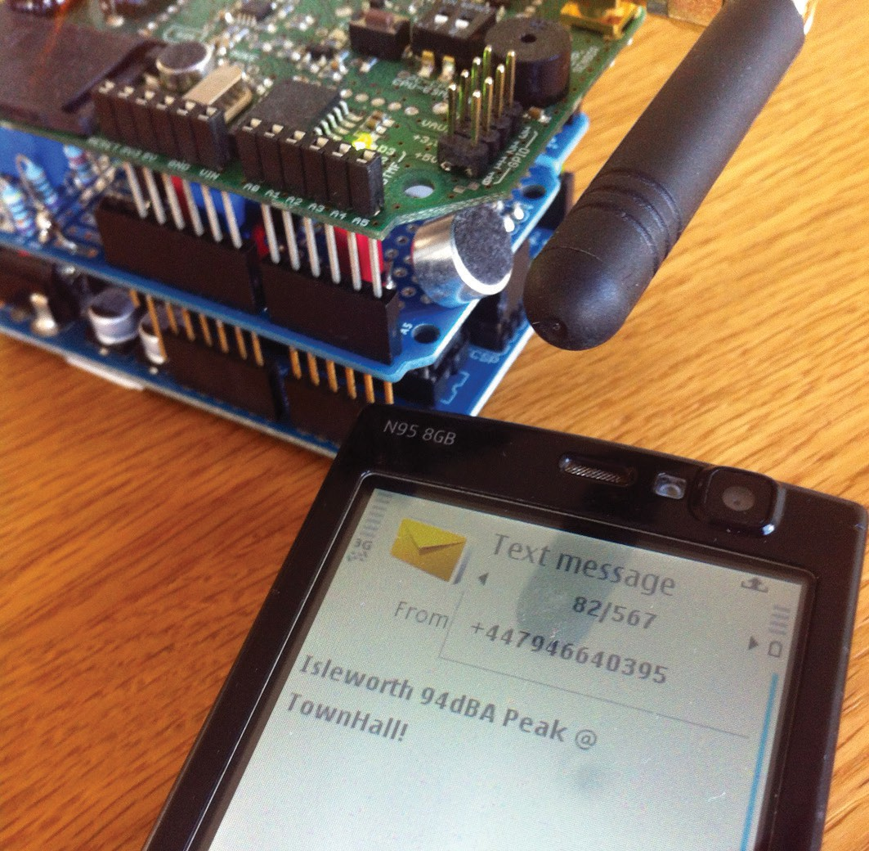

**Fig. 4.3** Photograph of the ‘I make someone responsible’ prototype (photo: Christian Nold)

bodies, politicians in favour of airport expansion, and the Prime Minister. Whilst a range of entities was discussed, there was no consensus about who should be held accountable. During the workshop, whenever voices were raised or a plane flew overhead, the prototype would send an SMS message that would be received with loud bleeps, and the group would respond with laughter. It was interesting to observe the way the prototype held the participants’ visual attention and tightly focused the discussion on technical interventions. Some participants were highly engaged by the confrontational approach of the pro- totype, and extended its logic by talking about an event when loudspeakers had been installed outside a politician’s house to wake them up with the noise

of the early morning flights. Others in the group felt that the targeting logic of the prototype was too personal: they wanted to make the SMS messages more ‘public’ by redirecting them to a Twitter stream or automated hotlines, ‘I think tweeting may well be a more acceptable way of doing that and it’s in the public domain so you can see there have been 80 tweets at that time in the morning and it’s not going to a direct person’.

From my perspective, the prototype allowed the group to experience a new relational infrastructure that created a direct connection between a noise event and an actor who is regarded as responsible for it. This bypassed the technical mediators who currently deal with noise data. Instead of the sanctioned infra- structure of the annoyance metric that traces long-term patterns, the prototype is a technical hack that uses the decibel data to act like a shouted complaint at a politician in the street. The prototype triggered a group discussion about the strategies and tactics that a noise-monitoring network should adopt. Should it force new political connections by holding individuals accountable, or should it focus on building a data repository that is more acceptable to the current logic of the airport’s data practices? At stake were different ways of staging annoyance. Yet the diversity of reactions among the workshop participants made it clear that any infrastructure designed for this collective could not adopt a single way of staging annoyance, but would have to support a multiplicity of approaches.

# Prototype 4 : ‘ I Turn Noise into Numbers ’

This prototype (Fig. 4.4) uploads sound pressure measurements at regular intervals to an online repository, where it is presented as a time series. The noise of passing aircraft can be identified as visual spikes on the online graph. The prototype directly addresses the requests by residents for a static monitoring device that can be placed in their own home to provide evidence of their noise exposure. The composition and function of the device is as follows:

sound sensor > decibel data > online data archive

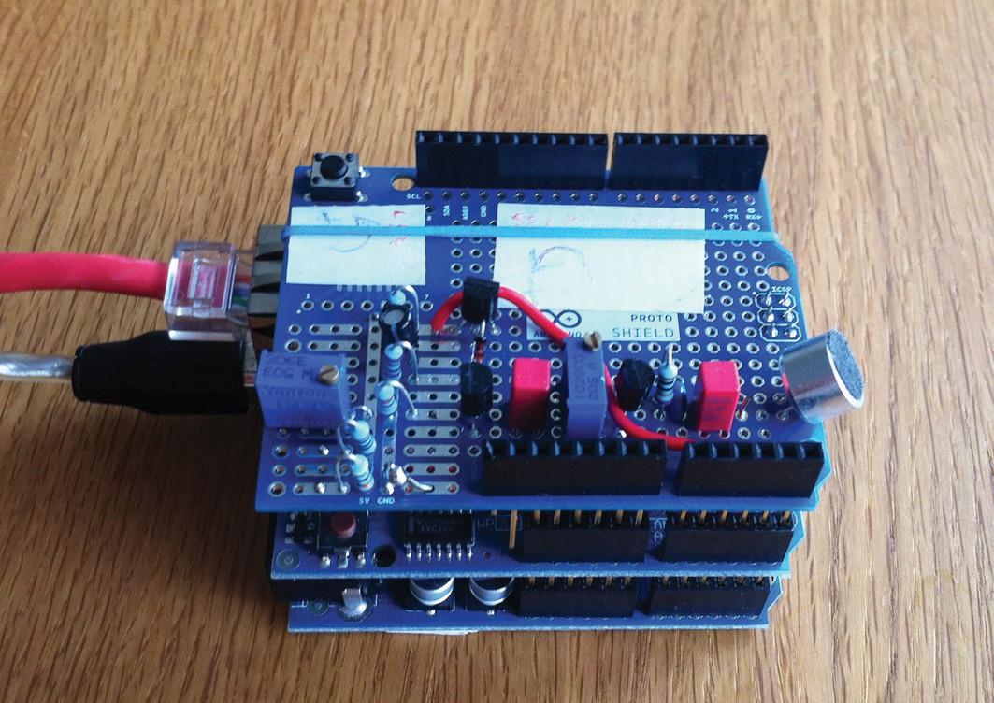

**Fig. 4.4** Photograph of the ‘I turn noise into numbers’ prototype (photo: Christian Nold)

During the workshop, this prototype triggered the least discussion and provoked no disagreement among the group. The residents asked practical questions about where it could be located in their home and whether future versions could be made more accurate. Compared with the previous prototypes, this one is the most similar in function to existing, official noise meters, which produce decibel numbers as their output. The innovation of the device is that its low cost would allow the participants to carry out their own data gathering by choosing where and how they monitored noise, whilst still allowing a connection to the existing data infrastructure of the airport. Yet at a conceptual level, the prototype was not challenging and seemed to be largely familiar to the participants. Despite the fact that it was not clear exactly what data would be collected, or what would be done with it, the prototype was treated as a tool that could be used, rather than a provocation that needed to be discussed. At the end of the workshop I asked the participants if they wanted to borrow any of the prototypes, and half of the group excitedly asked to take this prototype home with them.

# Infrastructuring a Noise Monitoring Collective

The main results from the workshop were that a number of people were now enthusiastic about participating in a noise-monitoring network, and I learnt a huge amount about the way noise and noise metrics function in the local area. I had identified a prototype that people wanted to use, and gathered insights for future prototypes. I installed the ‘I turn noise into numbers’ prototype in one of the participant’s homes, where it was in operation for three months. During this time, one of the other workshop participants informed me when the device temporarily stopped sending data, so I knew that at least some people were paying attention to the data feed. This encouraged me to continue the process and build a new device that would incorporate the insights from the workshop. I tried to enrol additional actors to put together a loose team to develop and test the prototypes as well as gather financial support for the hardware. Over a period of a year, I assembled a network that included a charitable foundation that funded the hardware, a local council that agreed to co-locate a prototype alongside their noise monitors, a noise pressure group who provided strategic advice as well as individual local residents, and sound artists and academics working on noise and biodiversity. The hardware and software were created as a loose collaboration with the sound artists, an academic and a Heathrow resident who is a programmer. It was not only the issue of Heathrow noise that encouraged people to join the network, but also the practical development of the device, which became a tangible focal point for the gathering of this network. During a follow-up workshop at which the group met to work on the program- ming, one of the members spoke about their surprise at the mix of collaborators involved with the prototype, which included personal friends, family members and local residents, as well as institutions and pressure groups.

# Prototype 5 : ‘ I Quantify AND Broadcast’

This final prototype (Fig. 4.5) uses a Raspberry Pi computer and a calibrated measurement microphone, which were chosen for their measurement accuracy,

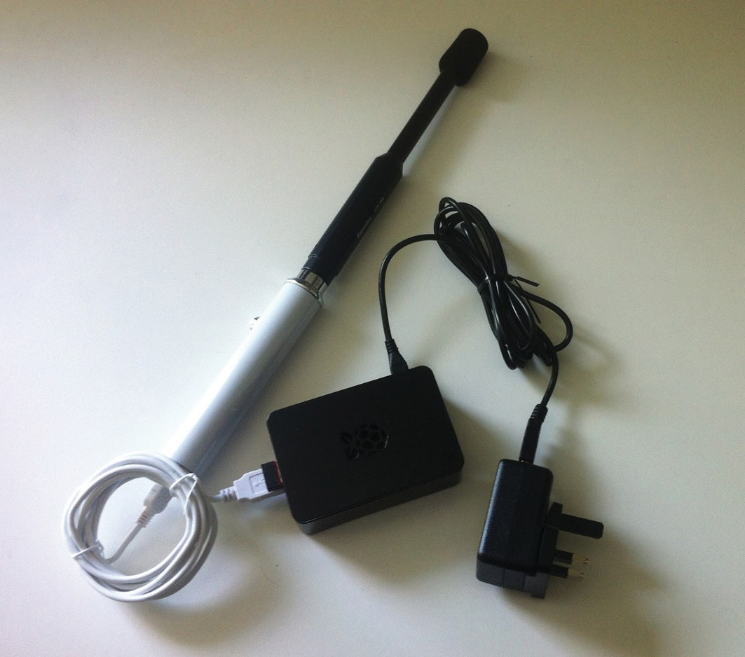

**Fig. 4.5** Photo of the ‘I quantify AND broadcast’ prototype (photo: Christian Nold)

low unit cost and availability for the foreseeable future. The key feature of the device is that it sets up two parallel infrastructures and ways of dealing with sound. The first treats voltage changes at the microphone as acoustic pressure, which is converted into the LAeq official noise metrics of the airport. A script on the Raspberry Pi samples, filters and uploads the data to an online reposi- tory where it is viewable as a time-series graph and historical data. The second approach treats the voltage changes at the microphone as a soundscape, and creates a sound stream that is available as a real-time internet radio station. A computer program continuously encodes the microphone data and posts it to a public server where listeners can experience the soundscape. These two infrastructures are intended to materialise the diversity of actors involved in the assembly of the monitoring prototype and the opinions articulated during

the workshops. The device relies on an ontology of noise as decibel measure- ment in order to enrol existing institutional actors such as the airport, but also adds an ontology of sound as audio broadcast that is alien within the context of Heathrow noise pollution monitoring. While at a conceptual level this doubling up seems contradictory, at a material and technical level it is perfectly normal to run multiple software scripts simultaneously. In fact, virtually all computer systems run hundreds of scripts as part of their operating system. Using a design approach to deal with the ontological controversy about how to stage annoyance allows an additive methodology: devices can stack multiple ontolo- gies on top of each other rather than having to replace one logic with another. The aim of the two infrastructures is not just to represent diversity but also to enable a multiplicity of sound practices that support each other. During the EU-funded research project, our sound-monitoring activities had received the criticism that residents were measuring spikes caused by other noise sources and not just aircraft. By synchronising the sound and data feeds, this prototype can verify the source of a spike, as well as allow people to visually identify and listen to particularly loud or quiet parts of the soundscape. In this way, the two ontologies of the prototype start to overlap and mutually support each other.

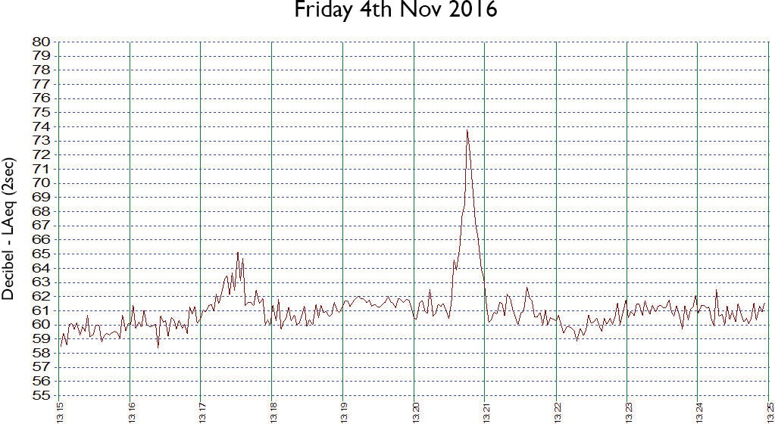

**Fig. 4.6** Windsor prototype data being used to make a noise complaint about an off-track aircraft

At the time of writing, in November 2016, three prototypes have been installed, with the oldest, in Windsor, having collected more than a year’s worth of data. The Windsor device is 6.5 km west of the Heathrow runways; another is in Hanwell, 9.5 km east of the runways; and the last is in Camberwell, 24 km from the runways. Based on these installations, it has been possible to make some observations about the sound practices they have enabled. The Windsor device is hosted in the garden of a member of the development team who is skilled in data analysis. He has used the data to identify particularly disruptive flights by correlating noise peaks with third party aircraft data as evidence for making complaints to the airport (Fig. 4.6). In his complaint he writes, ‘on Fri 4th Nov at 13:20, BAW17 directly overflew, my house at 73.8db LAeq2s. It was off track and should have been 1km further north. The usual noise level of outbound flights going north is around 60–65db. Please discipline the pilot. Please contact me to confirm this complaint. I attach screen clips of noise level and track’. The prototype functioned like this:

sound sensor > decibel data archive > disruptive sound event >

evidenced complaint to authorities

The host of the Windsor device also used the prototype to try and determine whether ‘Heathrow [is] getting better or worse and how fast’. He built custom software to track noise exposure episodes at different decibel levels to identify long-term trends in the airport’s operation. What is interesting about this approach is that it steps beyond the logic of individual complaints to focus on the creation of longitudinal data models that until now had been the reserve of the airport. In its public literature, the airport continually makes the claim that ‘Heathrow is getting quieter’ (Heathrow Airport Limited 2013: 14) based on graphs showing shrinkage in the annoyance contour. Yet based on a visualisation of thirteen months of data from the Windsor prototype, it has been possible to demonstrate that at this site and over this duration, the noise has remained remarkably constant (Fig. 4.7). This visualisation thus presents situated evidence that can interrogate the claims of the airport. What is key about this long-term visualisation is that it starts to rescale the prototype into a spokesperson that

can stand alongside the official noise metrics and begin to challenge the airport’s Leviathan. I suggest that this approach points the way towards a model for staging annoyance based on situated empirical data collected by residents rather than aggregated social surveys. The dataset has also been shared with the Aviation Forum and the environmental officers of the local council, and presents a new way for residents to collaborate with the local authorities in holding the airport to account. The prototype thus enacts the following infrastructure:

sound sensor > decibel data archive > long term metric to monitor changes in airport operation

The internet radio station part of the prototype has also enabled two public art installations that were attended by over 1200 people. These installations allowed visitors to see the data feeds, read an account by one of the prototype hosts and listen to the live soundscapes at Windsor and Camberwell in order to compare them (Fig. 4.8). The hosts of the prototypes were present to talk to members of the public about their own experience with noise, as well as the wider issue of Heathrow. While the visitors expected aircraft noise in Windsor,

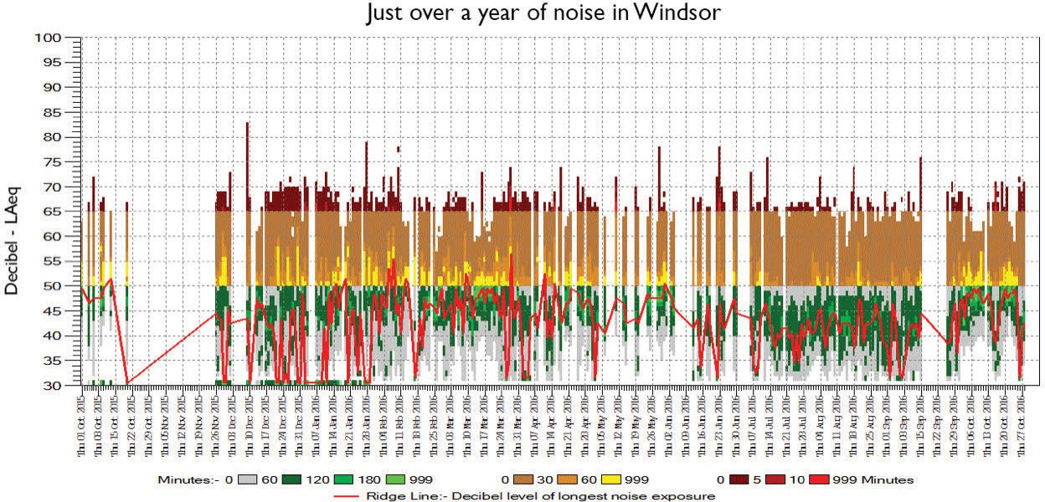

**Fig. 4.7** Visualisation of thirteen months of data from the Windsor prototype. Each day is represented by a vertical line with yellow indicating many loud episodes above 50dB LAeq2s. The red line indicates the noise trend

the frequent and loud aircraft in Camberwell, which was 24 km from the run- ways and outside the annoyance contours, shocked them. This was the first time that many visitors had paid active attention to aircraft noise and noted the different sonic qualities of the aircraft and their effects on wildlife. When I was present, I would draw people’s attention to the way birds seemed to screech in shock from the aircraft. Even after a jet passed, it was possible to hear the lingering effect on the birds as they continued to squawk. Despite the fact that the visitors were listening remotely, the sound installation created a tangible experiential connection to Heathrow. In this deployment, the prototype had the following infrastructure:

sound sensor > online radio station > public sound installa- tion > visitors experience heathrow noise

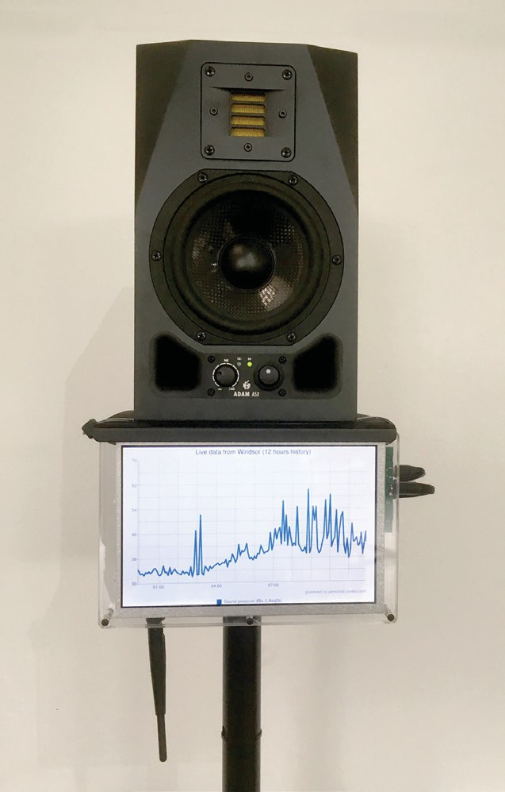These multiple functions of the prototype as noise complaint, monitoring device and sound installation have

demonstrated the versatility of the device. The prototype has enabled a variety of different infrastructures that engage existing participants in the controversy, such as the local councils and airport authorities, but has also made a connection to a broader audi- ence of people who did not have any specific personal relation to the issue of Heathrow. The project is ongoing and growing, as there are other Heathrow residents waiting to install prototypes at their homes. The plan for this loose prototype collective is to support the deployment of a dozen devices and

continue developing functionality that could enable programmatic sound

**Fig. 4.8** Detail of the ‘Prototyping a new Heathrow Airport’ sound installation

identification of birds in order to demonstrate the broad impact of aircraft noise on living entities at Heathrow.

# Discussion

This chapter has added to the existing literature on controversies by out- lining an approach to turning controversies into questions of design, and by presenting preliminary results of my project to prototype the Heathrow noise pollution controversy. Key to my approach are the metaphors and methods of infrastructure and infrastructuring. My project sought to extend these using a method of scaling in order to identify and challenge the existing infrastructure of the Heathrow controversy. The combination of these two metaphors – infrastructure and scale – has highlighted the importance of the community annoyance metric as a key socio-technical device that con- nects aircraft, residents and governance, and one that has the capacity to structure decision making on the third runway. The metric functions as a spokesperson that speaks on behalf of residents about their experience of noise, yet acts against their wishes. The issue of Heathrow pollution actually consists of three different controversies: a media controversy around eco- nomic trade-offs, a failed political controversy about the number of people affected by noise, and an ontological controversy about how to stage annoy- ance. Yet the opponents to the airport extension have so far not made use of this ontological controversy. This case study presents a way of turning the ontological controversy of Heathrow into a space for participatory prototyp- ing. The prototype devices explored different ways of staging annoyance, and identified a need for multiple ways of providing evidence for the impact of noise. The prototyping process also resulted in the gathering of a loose col- lective focused on building a sound-monitoring network that could use the logic of sound measurement to allow targeted complaints and to develop a new metric that could challenge the airport’s claims, as well as allow a new public to experience and discuss the impact of Heathrow by listening remotely. This object-centred design approach made it possible to stack multiple ways

of staging annoyance within a single device and collective. The device points the way towards building alternative *spokespeople* that can act on behalf of local residents and speak about the impact of noise in multiple ways. This case study has demonstrated the unique qualities of a design approach that not only analyses a socio-technical controversy but also allows experimentation and intervention in it. It is worth speculating how many other controversies might benefit by being turned into questions of design.

# Ac k nowle dge m e nts

This research was made possible through collaboration with Andrew Hall, Grant Smith, Max Baraitser Smith and Matthias Stevens. The research was part of the Hubbub project investigating rest and its opposites, supported by the Wellcome Trust [103817/Z/14/Z]. Thanks to Noortje Marres, Alex Wilkie and Daniela Boraschi for their feedback on the chapter.

# References

Airports Commission, *Airports Commission: Final Report* (London, 2015) < https://assets. publishing.service.gov.uk/government/uploads/system/uploads/attachment_ data/file/440316/airports-commission-final-report.pdf> [accessed 30 April 2018].

——‘Member of the Public 16: Noise Discussion Paper’ (London, 2013) <https://[www.](http://www/) gov.uk/government/publications/stakeholder-responses-to-airports-commission- discussion-papers> [accessed 15 December 2015].

Airportwatch, ‘2M Group of Councils Call for New Study into Attitudes to Aircraft Noise’, *Airportwatch* (2013) <<http://www.airportwatch.org.uk/2013/09/2m-> group-of-councils-call-for-new-study-into-attitudes-to-aircraft-noise/> [accessed 4 December 2013].

Berg, M., ‘The Politics of Technology: On Bringing Social Theory into Technological Design’, *Science, Technology & Human Values*, 23 (1998), 456–90.

Björgvinsson, E., P. Ehn, and P. A. Hillgren, ‘Agonistic Participatory Design: Working with Marginalised Social Movements’, *CoDesign*, 8 (2012), 127–44.

——‘Participatory Design and “Democratizing Innovation”’, in *Proceedings of the 11th Biennial Participatory Design Conference* (New York: ACM, 2010), pp. 41–50.

Braun, B., and S. J. Whatmore, eds, *Political Matter: Technoscience, Democracy, and Public Life* (Minneapolis: University of Minnesota Press, 2010).

Brooker, P., J. B. Critchley, D. J. Monkman, and C. Richmond, *Aircraft Noise Index Study: Main Report* (London, 1985) <https://publicapps.caa.co.uk/docs/33/ERCD 8402.

PDF> [accessed 30 April 2018].

Callon, M., and B. Latour, ‘Unscrewing the Big Leviathan: How Actors Macro-Structure Reality and How Sociologists Help Them to Do So’, in K. D. Knorr-Cetina and A.

V. Cicourel eds, *Advances in Social Theory and Methodology: Toward an Integration of Micro- and Macro-Sociologies* (New York: Routledge, 1981), pp. 277–303.

Civil Aviation Authority, *The Noise and Number Index* (London, 1981) <https:// publicapps.caa.co.uk/docs/33/ERCD7907.pdf> [accessed 30 November 2012].

Civil Aviation Authority, and Bureau Vertias, *Attitudes to Noise from Aviation Sources in England Non SP Peer Review* (London: Department for Transport, 2007).

Le Dantec, C. A., ‘Participation and Publics: Supporting Community Engagement’, in *Proceedings of the SIGCHI Conference on Human Factors in Computing Systems* (New York: ACM, 2012), pp. 1351–60.

Le Dantec, C. A., and C. DiSalvo, ‘Infrastructuring and the Formation of Publics in Participatory Design’, *Social Studies of Science*, 43 (2013), 241–64.

Le Dantec, C. A., et al., ‘Publics in Practice: Ubiquitous Computing at a Shelter for Homeless Mothers’, in *Proceeding CHI ‘11 Proceedings of the SIGCHI Conference on Human Factors in Computing Systems* (New York: ACM, 2011), pp. 1687–96.

Department for Transport, *Heathrow Airport Year 2014 Actual Modal Split Average Summer Night Leq Noise Contours*, *GOV.UK* (2014) <https://[www.gov.uk/](http://www.gov.uk/) government/publications/noise-contours-on-os-maps> [accessed 8 December 2015].

DiSalvo, C., et al., ‘Making Public Things: How HCI Design Can Express Matters of Concern’, in *CHI 2014: Conference on Human Factors in Computing Systems* (New York: ACM, 2014), pp. 2397–406.

Ehn, P., ‘Participation in Design Things’, in *Proceeding PDC ‘08 Proceedings of the Tenth Anniversary Conference on Participatory Design 2008* (Indianapolis, IN: Indiana University, 2008), pp. 92–101.

——*Work-Oriented Design of Computer Artifacts*, *Stockholm Arbetslivscentrum* (Stockholm: Arbetslivscentrum, 1988).

European Parliament, *The Environmental Noise Directive (2002/49/EC)* (2002) <http:// eur-lex.europa.eu/legal-content/EN/TXT/?uri=CELEX:32002L0049> [accessed 30 April 2018].

Fidell, S., ‘The Schultz Curve 25 Years Later: A Research Perspective’, *The Journal of the Acoustical Society of America*, 114 (2003), 3007–15.

Flindell, I. H., ‘Do Public Inquiries for Noise Control Serve a Useful Purpose? – An Acoustic Consultant’s View’, *Noise & Health*, 5 (2003), 31–38.

Flindell, I., and Associates, and MVA Consultancy, *Understanding UK Community*

*Annoyance with Aircraft Noise: ANASE Update Study* (2013) [<http://www.aef.org.](http://www.aef.org/) uk/uploads/understanding_uk_community_annoyance_for_2m_group.pdf> [accessed 30 April 2018].

Heathrow Airport, ‘HeathrowFacts and Figures’ (2015) <http://www.heathrowairport. com/about-us/company-news-and-information/company-information/facts-and- figures> [accessed 29 May 2015].

Heathrow Airport Limited, *A Quieter Heathrow* (London, 2013) <http://www.heathrow. com/file_source/HeathrowNoise/Static/a_quieter_heathrow_2013.pdf> [accessed 30 April 2018].

Hillgren, P. A., A. Seravalli, and A. Emilson, ‘Prototyping and Infrastructuring in Design for Social Innovation’, *CoDesign*, 7 (2011), 169–83.

Karasti, H., ‘Infrastructuring in Participatory Design’, in *PDC ‘14 Proceedings of the 13th Participatory Design Conference: Research Papers – Volume 1* (New York: ACM, 2014), pp. 141–50.

Karasti, H., and A-L. Syrjänen, ‘Artful Infrastructuring in Two Cases of Community PD’, in *Proceedings of the 37th Annual Hawaii International Conference on System Sciences, 2004* (New York: ACM, 2004), pp. 20–30.

Kuenssberg, L., ‘Heathrow Airport Expansion: A “Toxic Dilemma” for Ministers’, *BBC News*, 19 October 2015 <<http://www.bbc.co.uk/news/uk-politics-34568530>>

[accessed 23 October 2015].

Latour, B., and P. Weibel, eds, *Making Things Public: Atmospheres of Democracy* (Karlruhe and Cambridge, MA: MIT Press, 2005).

Marres, N., *Material Participation: Technology, the Environment and Everyday Publics*

(Chippenham, UK: Palgrave Macmillan, 2012).

——‘The Issues Deserve More Credit: Pragmatist Contributions to the Study of Public Involvement in Controversy’, *Social Studies of Science*, 37 (2007), 759–80.

Le Masurier, P., et al., *ANASE: Attitudes to Noise from Aviation Sources* (2007) <http:// [www.airportwatch.org.uk/wp-content/uploads/anase-report-2007.pdf](http://www.airportwatch.org.uk/wp-content/uploads/anase-report-2007.pdf)> [accessed 30 April 2018].

Mayor of London, *Airports Commission Discussion Paper 05: Aviation Noise The Mayor of London’s Response* (2013) <htt[ps://www.tfl.gov.uk/cdn/static/cms/documents/](http://www.tfl.gov.uk/cdn/static/cms/documents/) airport-commission-discussion-paper-05-noise-mayor-of-london-response.pdf> [accessed 26 May 2015].

Miedema, H. M. E., and C. G. M. Oudshoorn, ‘Annoyance from Transportation Noise: Relationships with Exposure Metrics DNL and DENL and Their Confidence Intervals’, *Environmental Health Perspectives*, 109 (2001), 409–16.

MIL Research Limited, *Aircraft Noise Annoyance around London (Heathrow) Airport*

(London, 1961).

Mol, A., ‘Ontological Politics: A Word and Some Questions’, in J. Law and J. Hassard, eds, Actor Network Theory and After (Oxford and Malden, MA: Blackwell Publishers, 1999), pp. 74–89.

Nelkin, D., ed., ‘Controversy: Politics of technical decisions’ (3rd ed.), Sage focus editions, Vol. 8. Controversy (Thousand Oaks, CA, US: Sage Publications, Inc., 1992).

Neumann, L. J, and S. L. Star, ‘Making Infrastructure: The Dream of a Common Language’, in *Proceedings of the Fourth Biennial Participatory Design Conference (PDC’96)* (Palo Alto: Computer Professionals for Social Responsibility, 1996), pp. 231–40.

Nold, C., ‘Device Studies of Participatory Sensing: Ontological Politics and Design Interventions’ (PhD Thesis, University College London, 2017).

——‘Micro/macro Prototyping’, *International Journal of Human-Computer Studies*, 81 (2015), 72–80.

Star, S. L., and K. Ruhleder, ‘Steps Toward an Ecology of Infrastructure: Design and Access for Large Information Spaces’, *Information Systems Research*, 7 (1996), 111–34.

——‘Steps Towards an Ecology of Infrastructure: Complex Problems in Design and Access for Large-Scale Collaborative Systems’, in *Proceeding CSCW ‘94 Proceedings of the 1994 ACM Conference on Computer Supported Cooperative Work* (New York: ACM, 1994), pp. 253–64.

Wynne, B., ‘Misunderstood Misunderstanding: Social Identities and Public Uptake of Science’, *Public Understanding of Science*, 1 (1992), 281–304.